QUESTION 4 SEQUENTIAL:

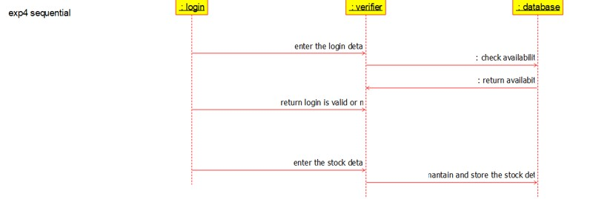

PACKAGE DIAGRAM:

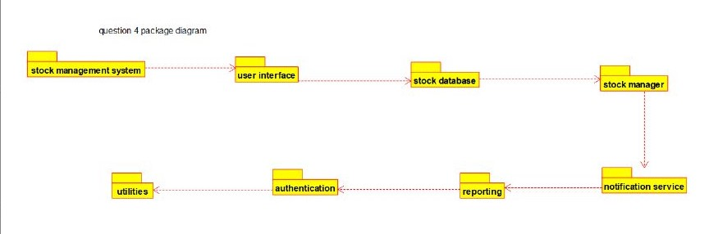

COLLABRATION 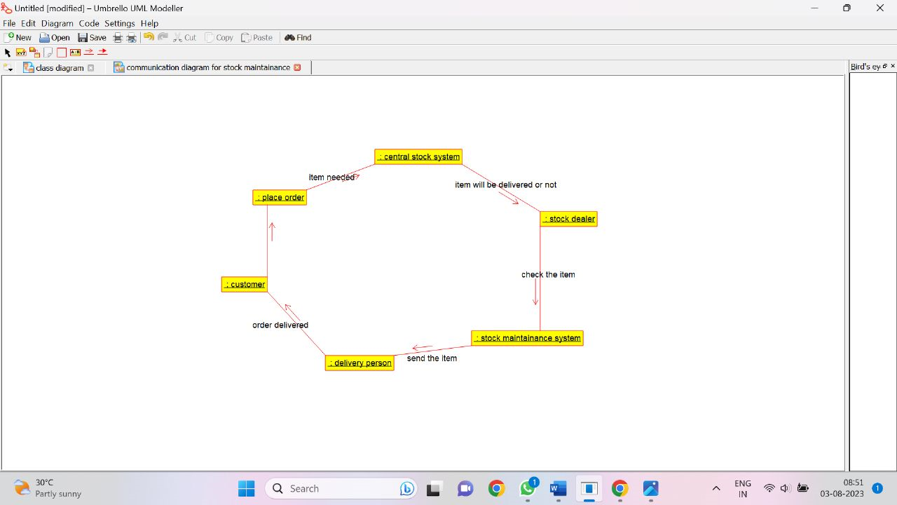QUESTION 5

ACTIVITY DIAGRAM

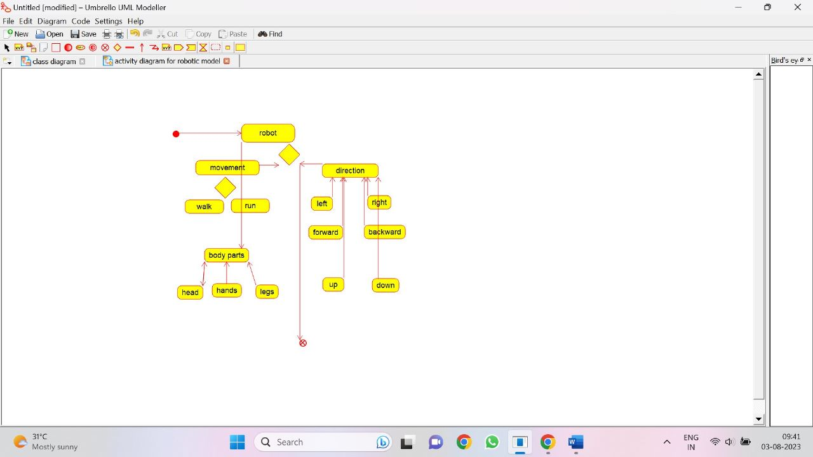

CLASS DIAGRAM

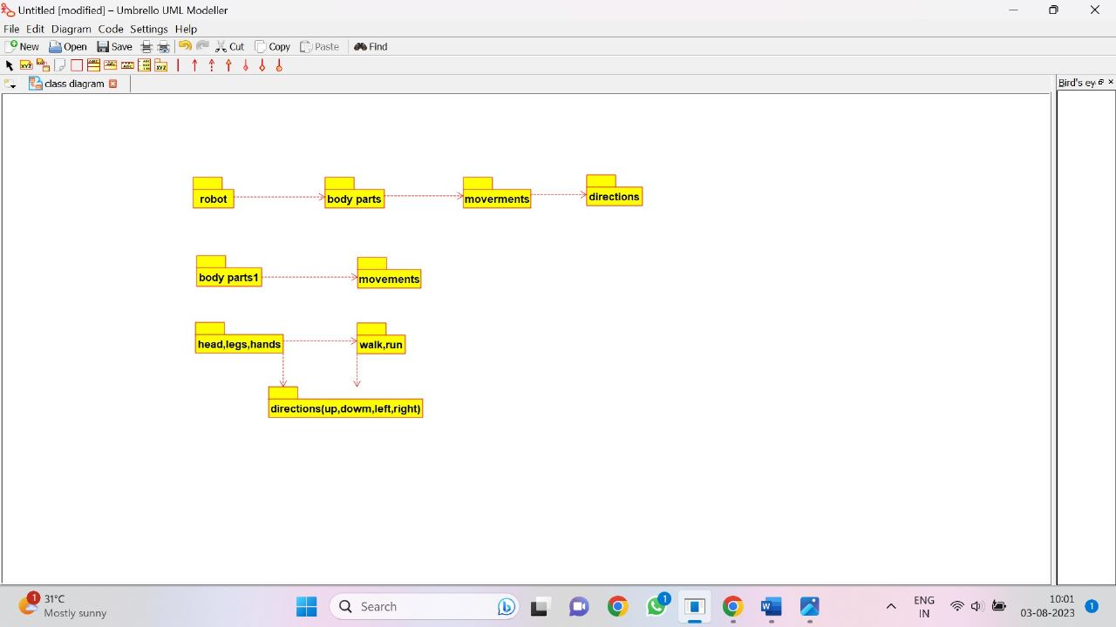

SEQUENCE DIAGRAM

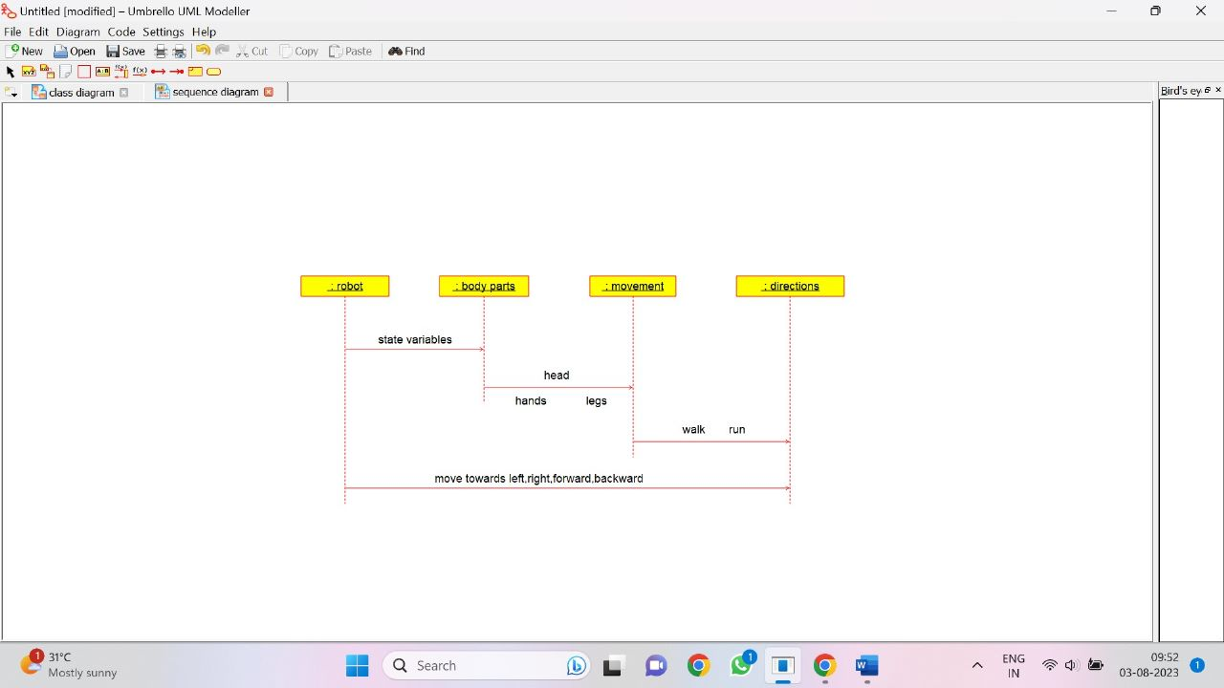

QUESTION 6:

ACTIVITY DIAGRAM

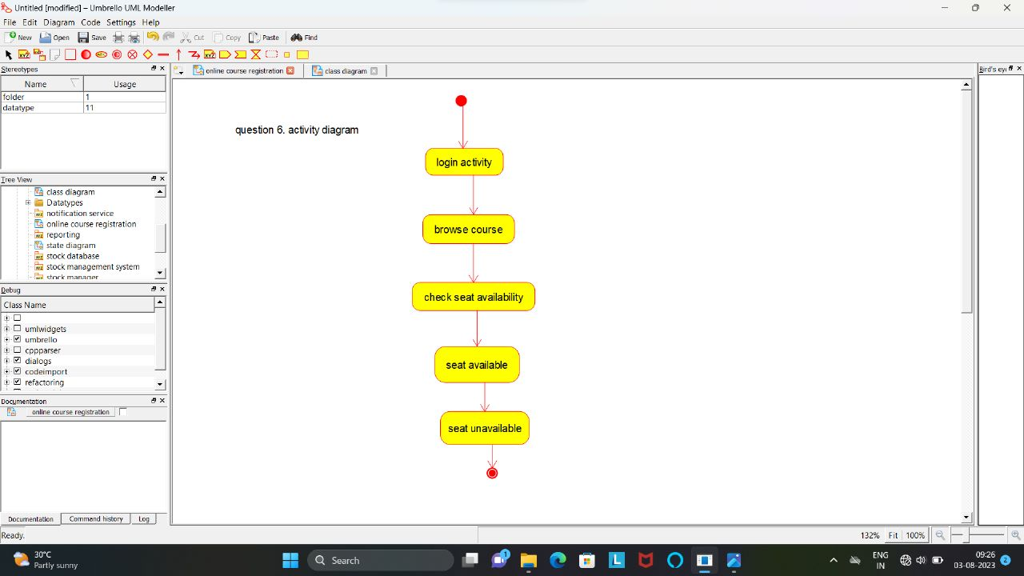

SEQUENCE DIAGRAM

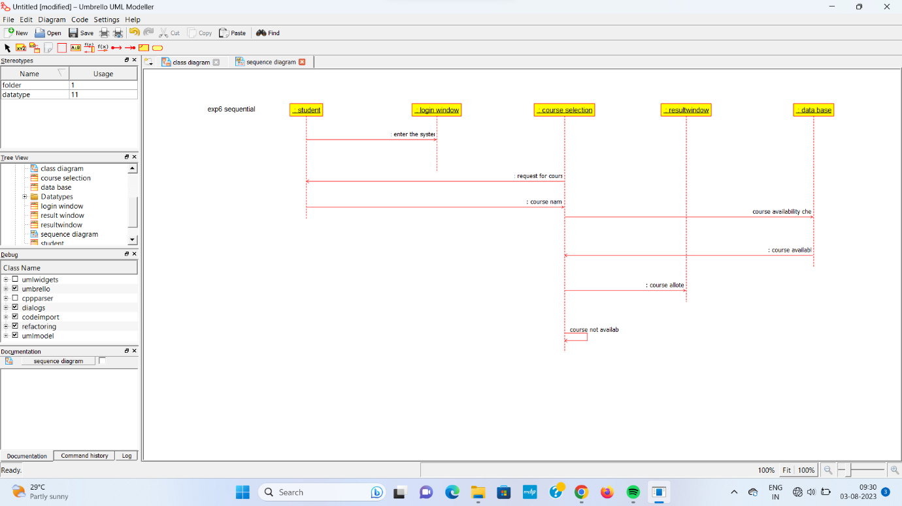

STATE TRANSITION DIAGRAM

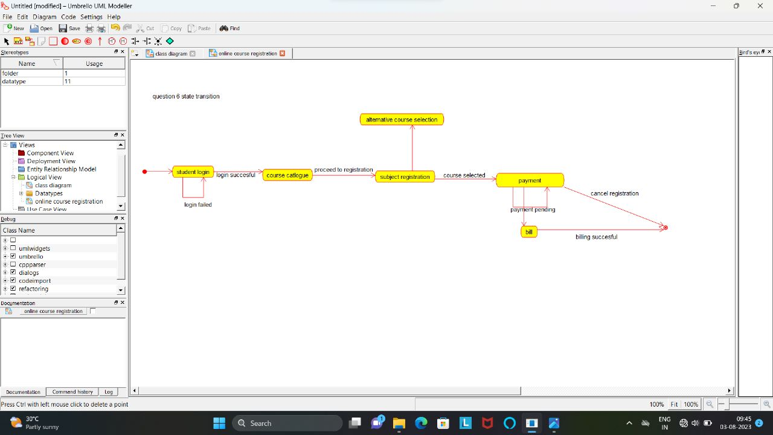

QUESTION 7:

ACTIVITY DIAGRAM

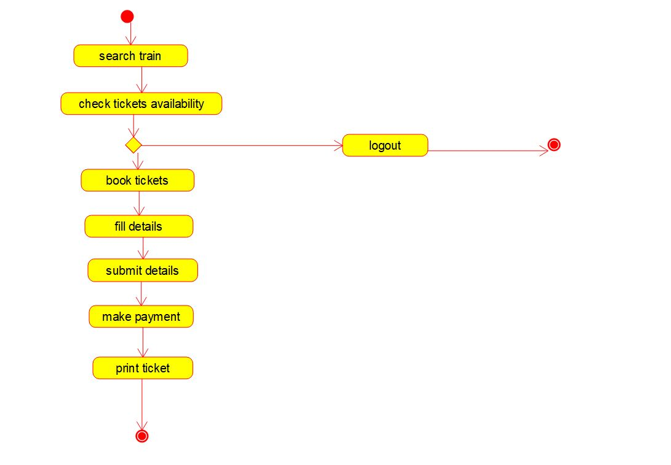

SEQUENCE DIAGRAM

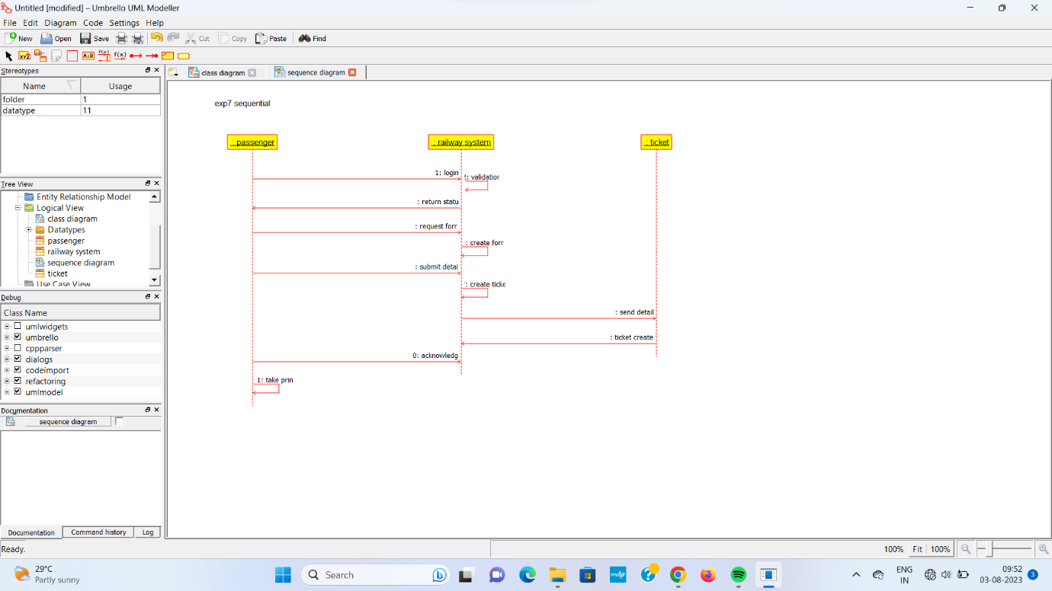

STATE TRANSITION DIAGRAM

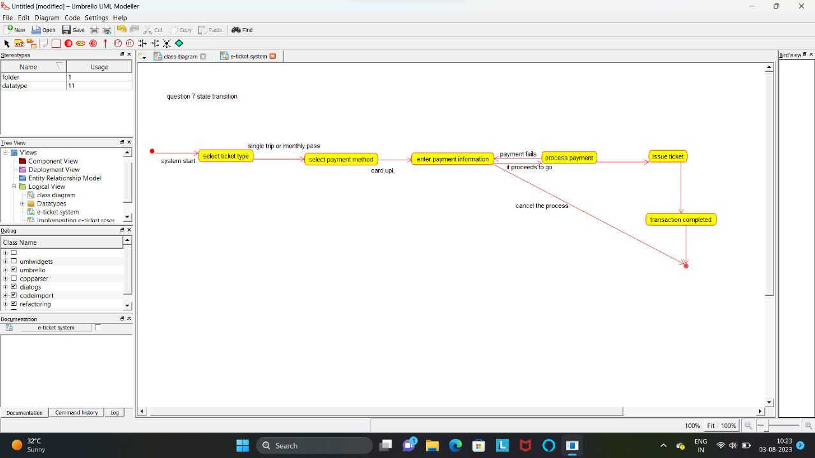

QUESTION 8:

PACKAGE DIAGRAM

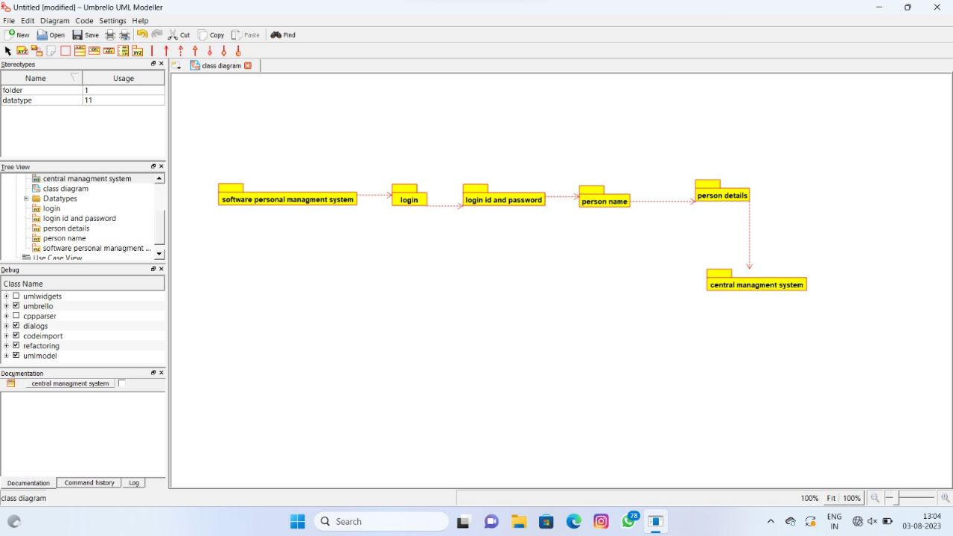

SEQUENCE DIAGRAM

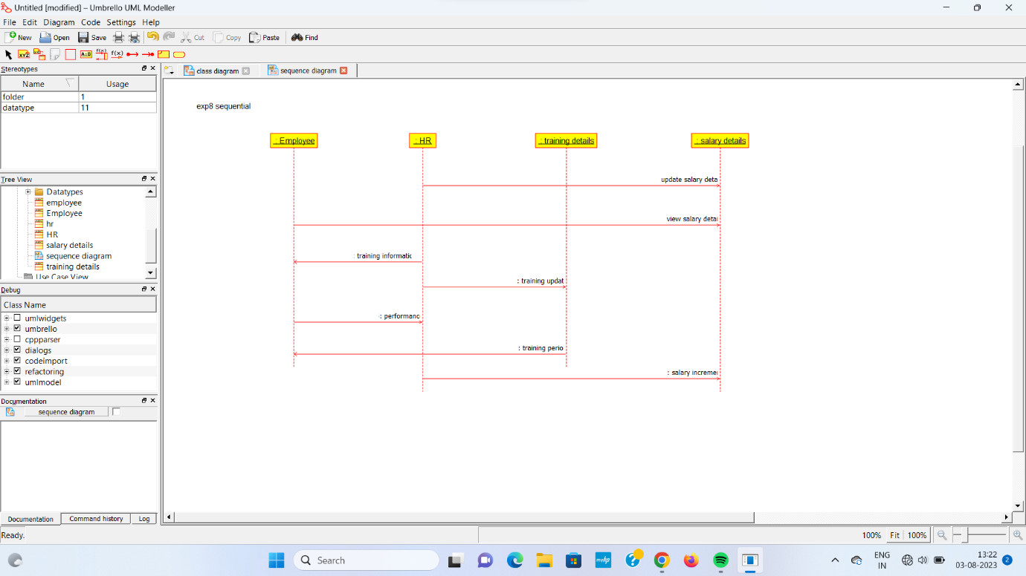

STATE TRANSITION DIAGRAM

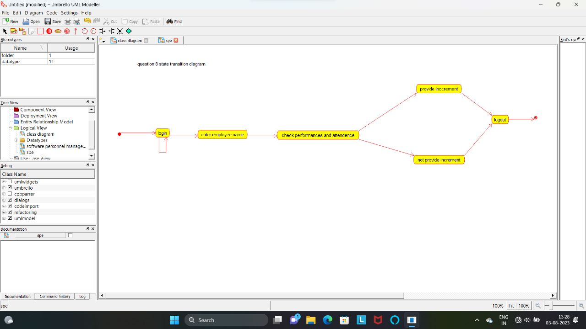

QUESTION 9:

DEPLOYEMENT DIAGRAM

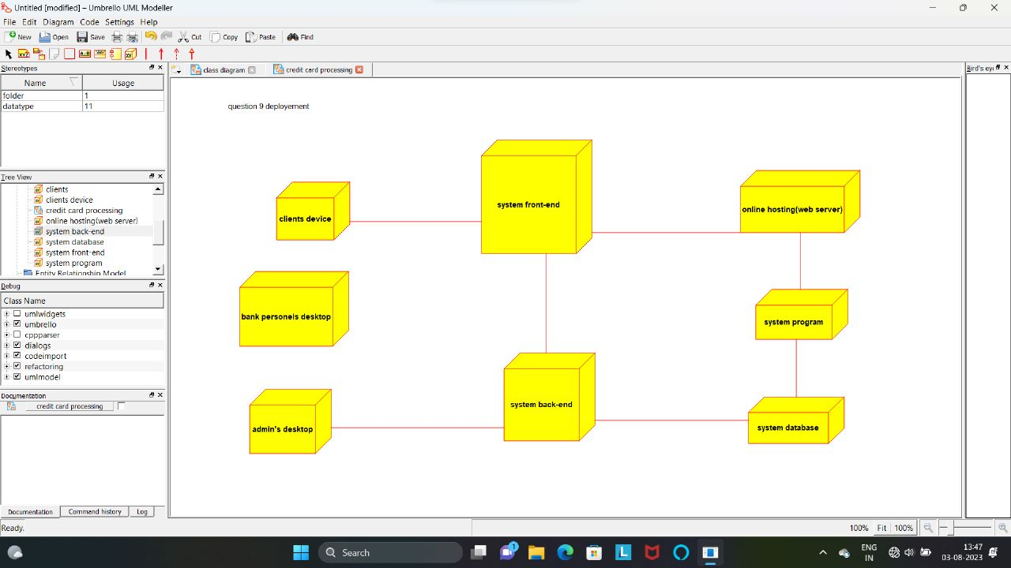

PACKAGE DIAGRAM

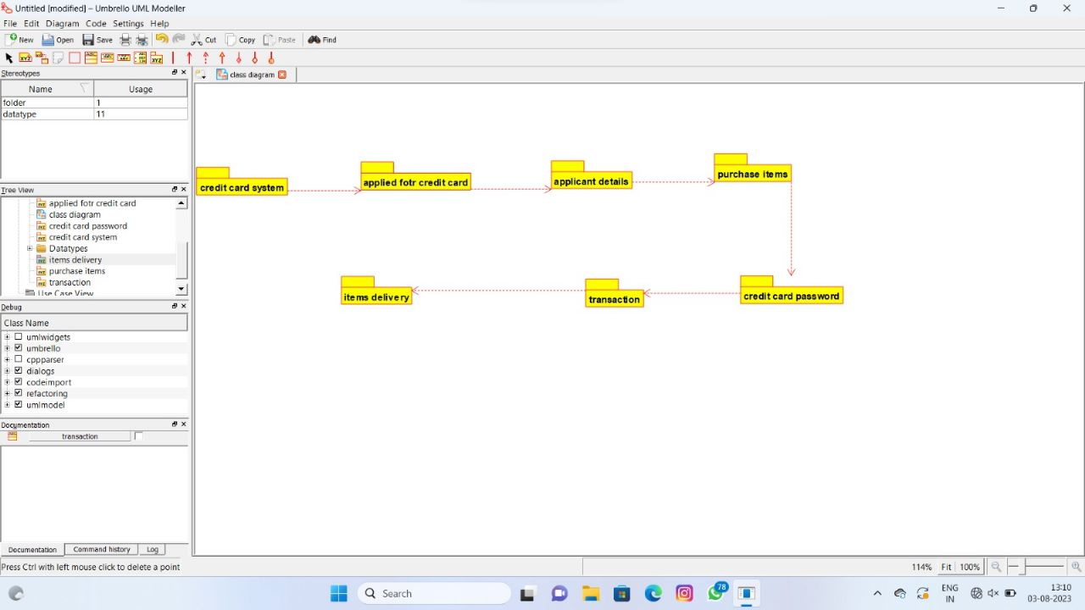

SEQUENCE DIAGRAM

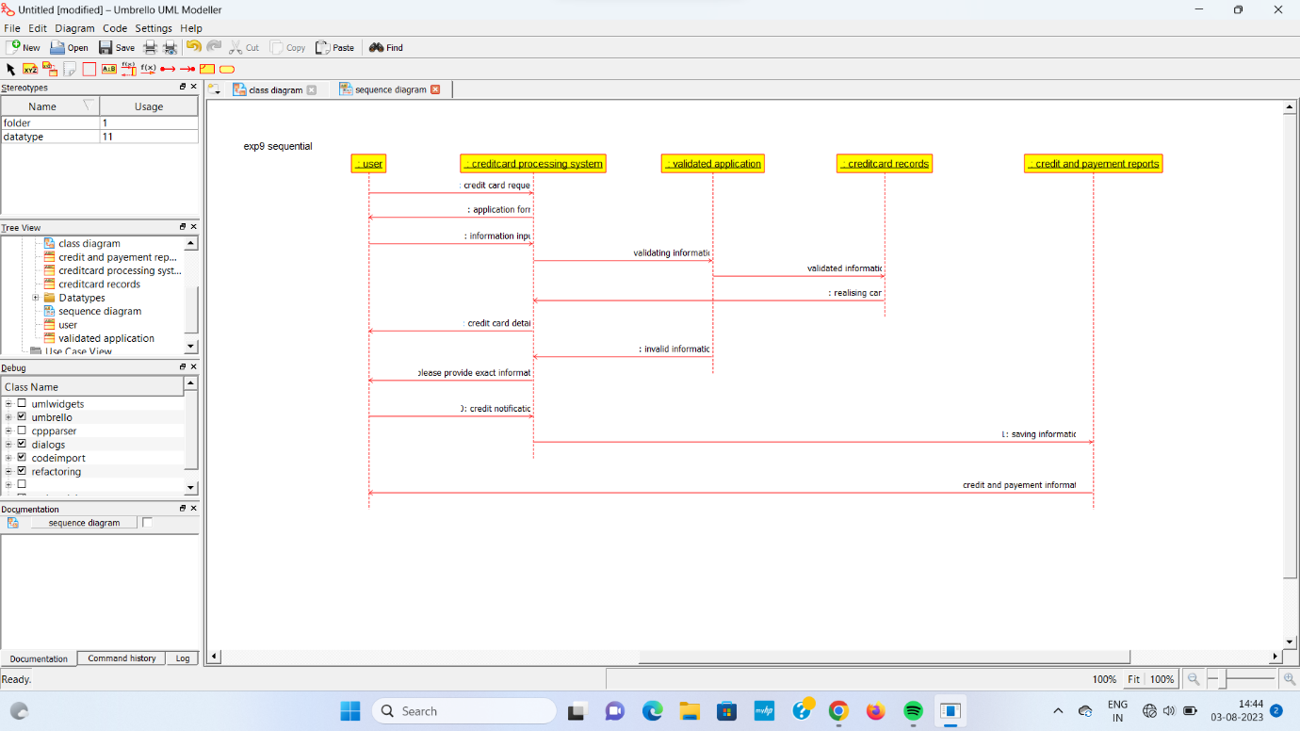

QUESTION 10:

ACTIVITY DIAGRAM

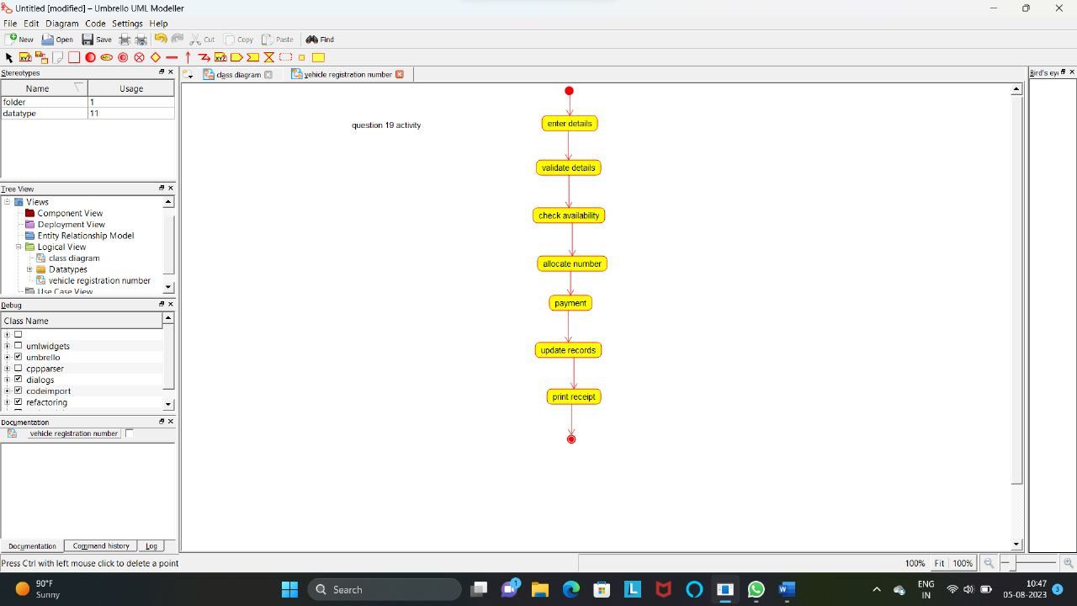

DEPLOYEMENT DIAGRAM

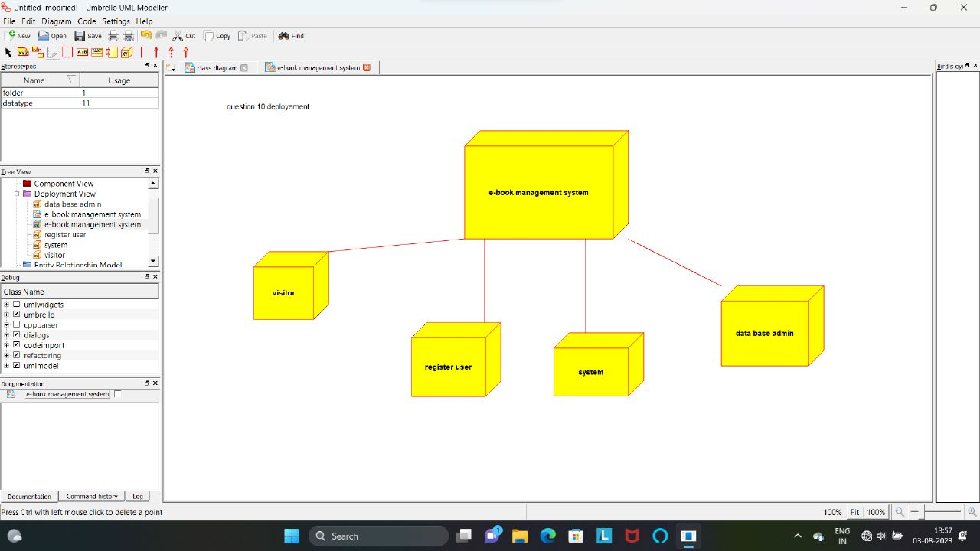

PACKAGE DIAGRAM

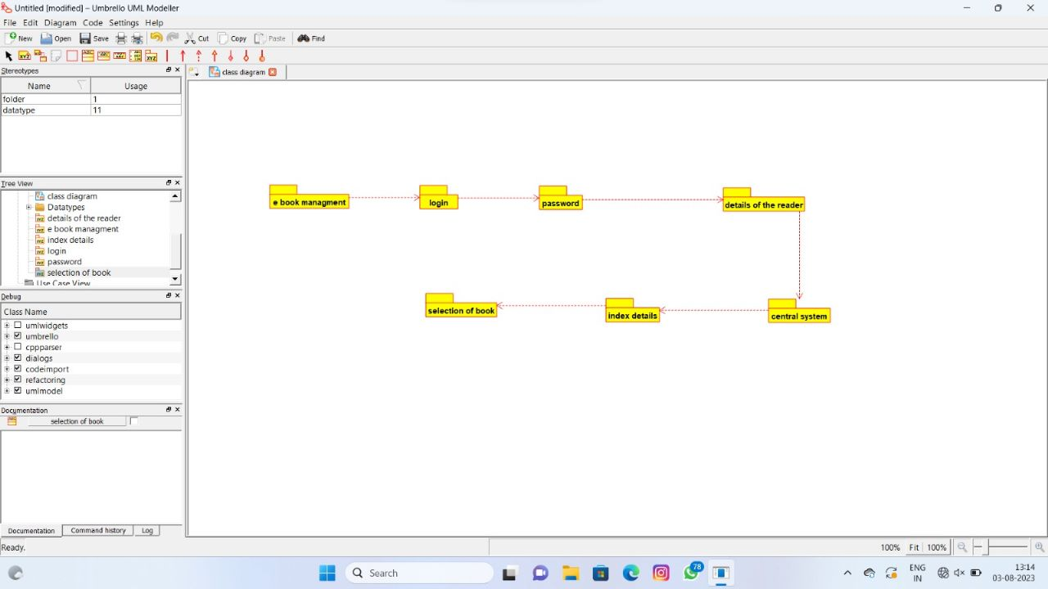

QUESTION 11:

ACTIVITY DIAGRAM

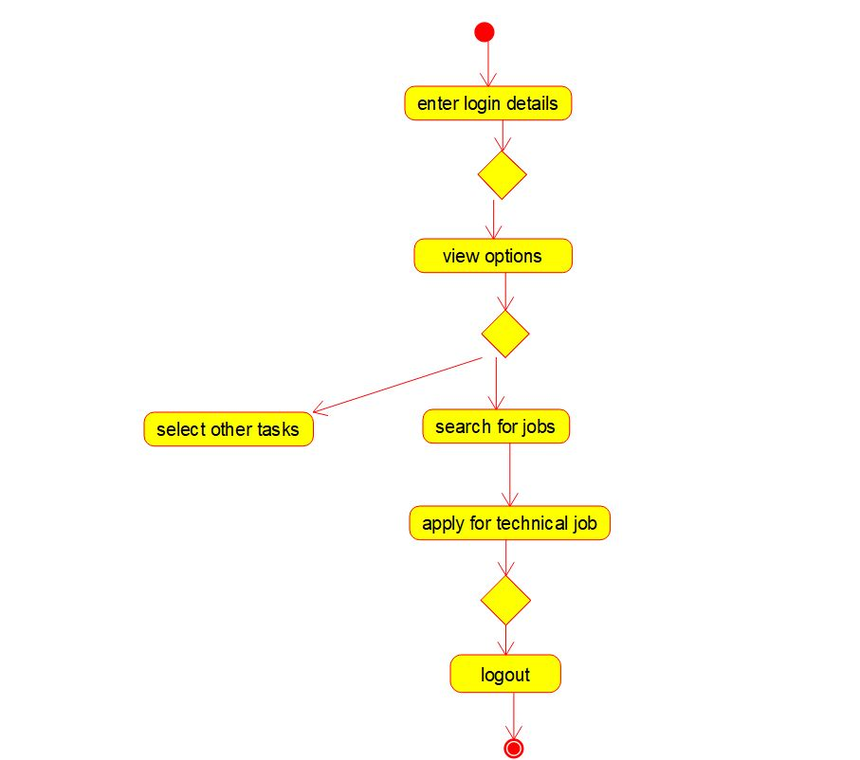

SEQUENCE DIAGRAM

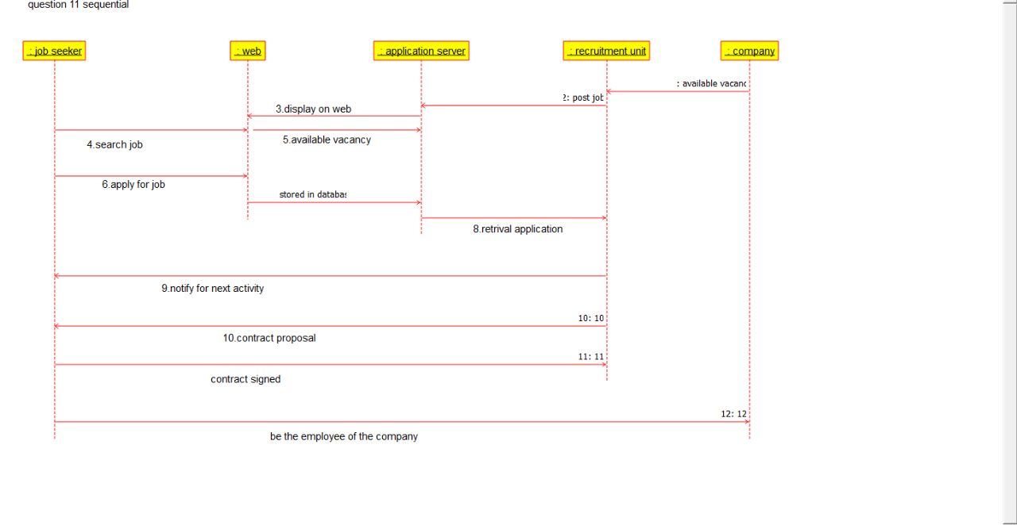

STATE TRANSITION DIAGRAM

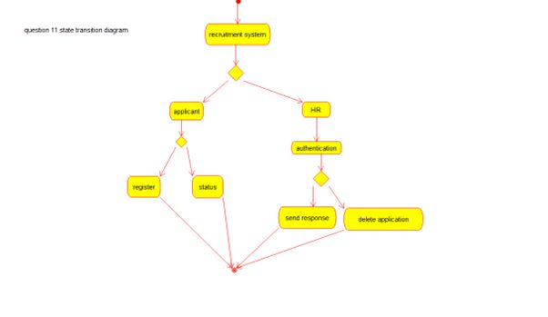

QUESTION 12:

ACTIVITY DIAGRAM

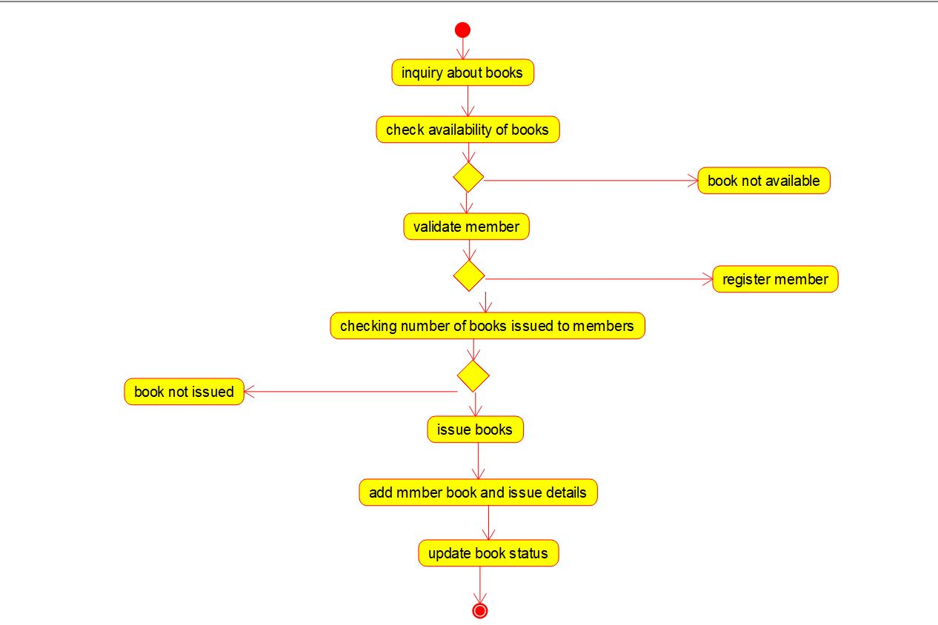

SEQUENCE DIAGRAM

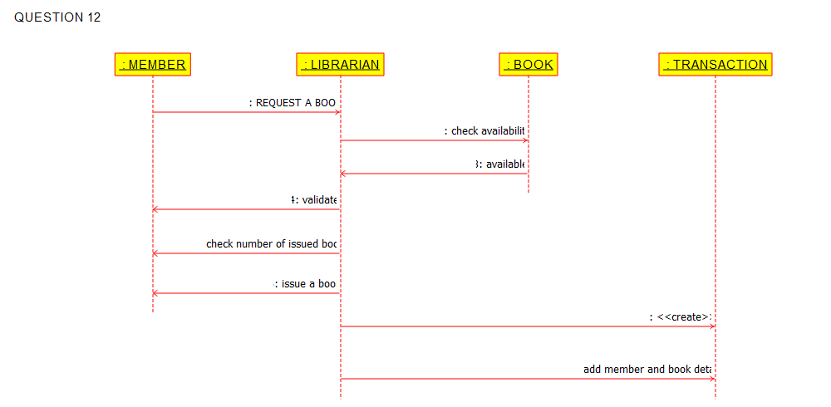

DEPLOYEMENT DIAGRAM

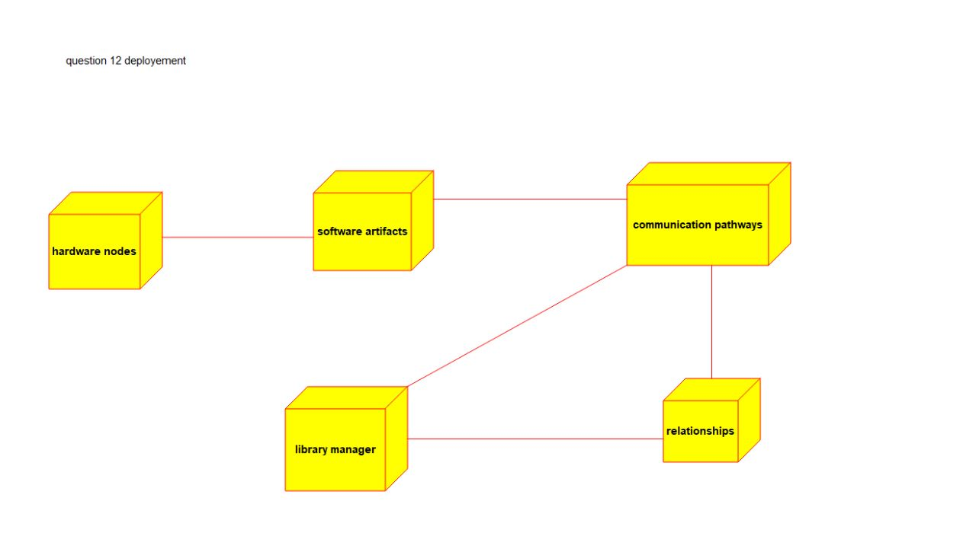

QUESTION 13:

ACTIVITY DIAGRAM

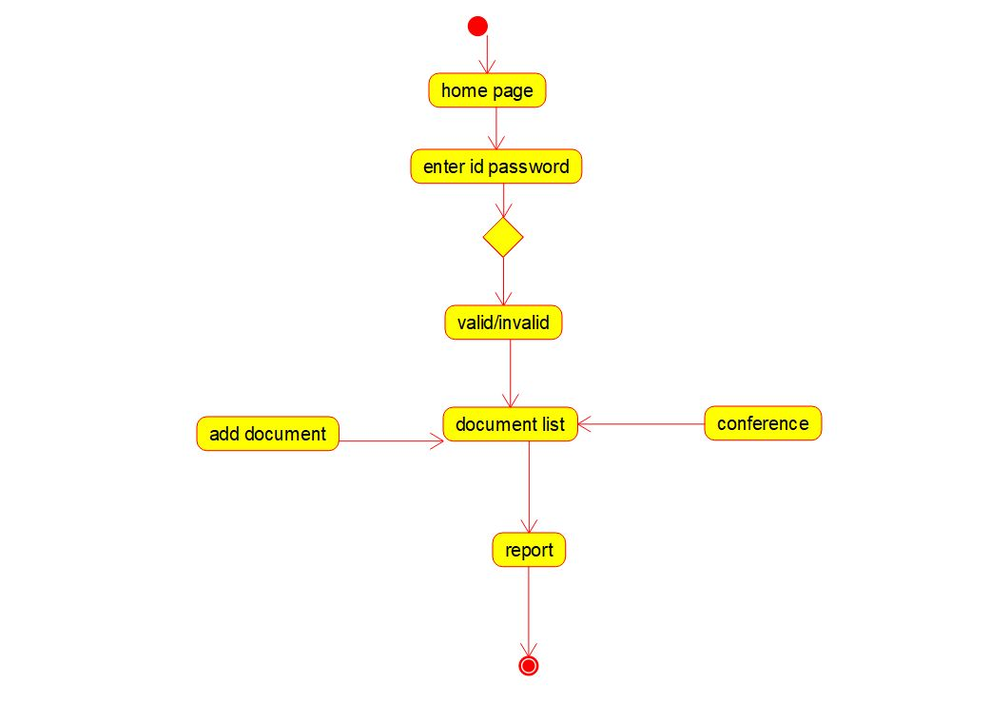

SEQUENCE DIAGRAM

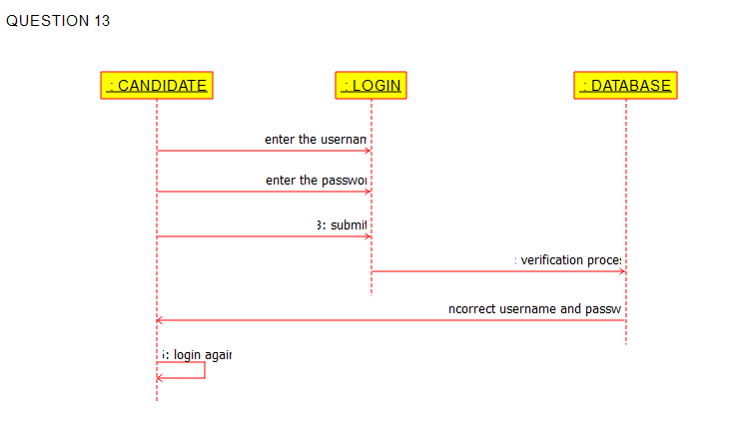

DEPLOYEMENT DIAGRAM

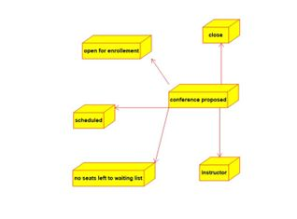  
QUESTION 14:

ACTIVITY DIAGRAM

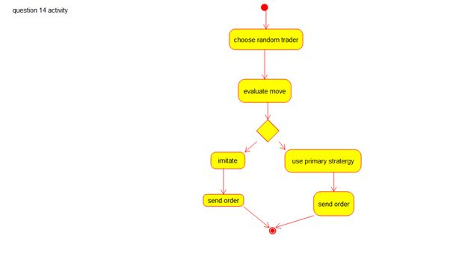

DEPLOYEMENT DIAGRAM

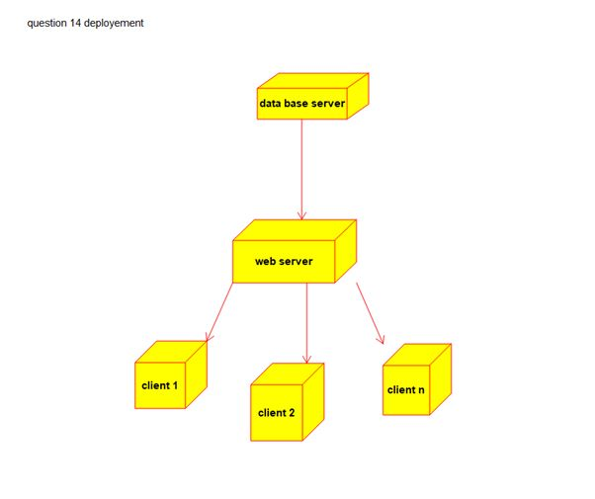

SEQUENCE DIAGRAM

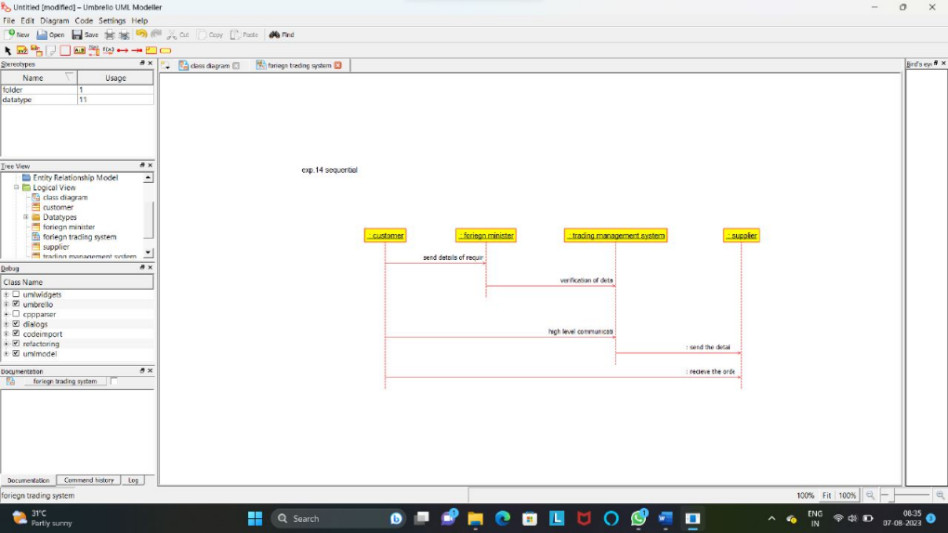

QUESTION 15:

SEQUENCE DIAGRAM

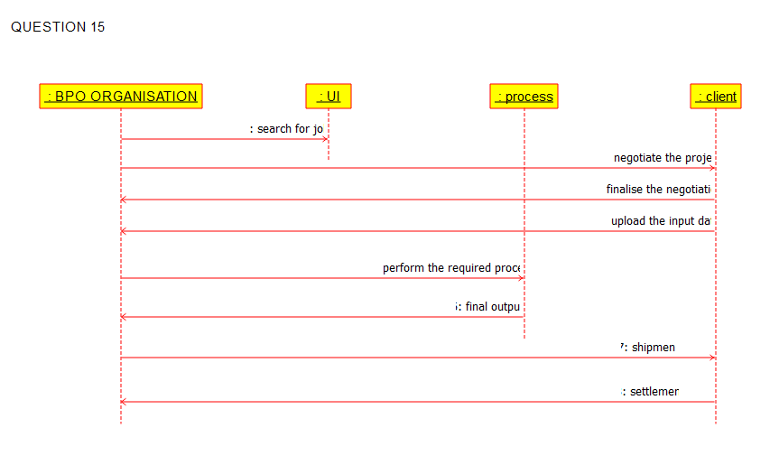

PACKAGE DIAGRAM

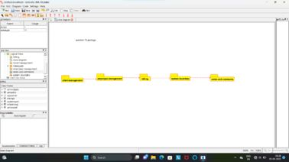

COLLABRATION DIAGRAM

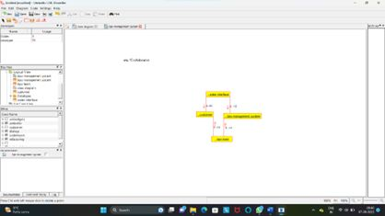

QUESTION 16:

ACTIVITY DIAGRAM

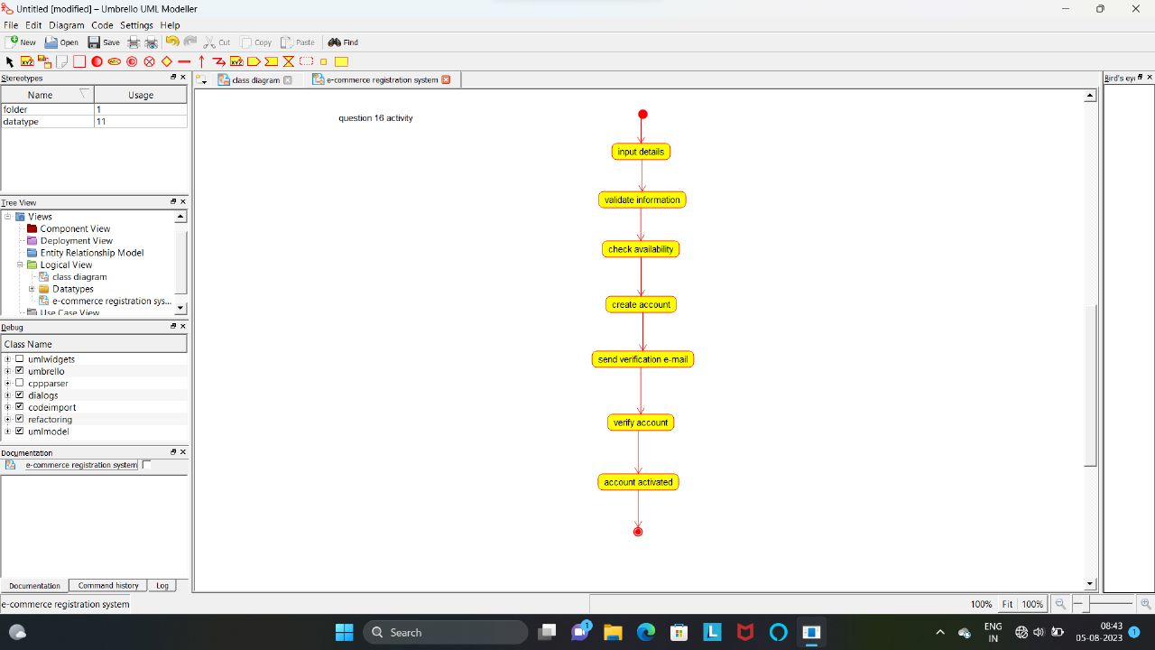

SEQUENCE DIAGRAM

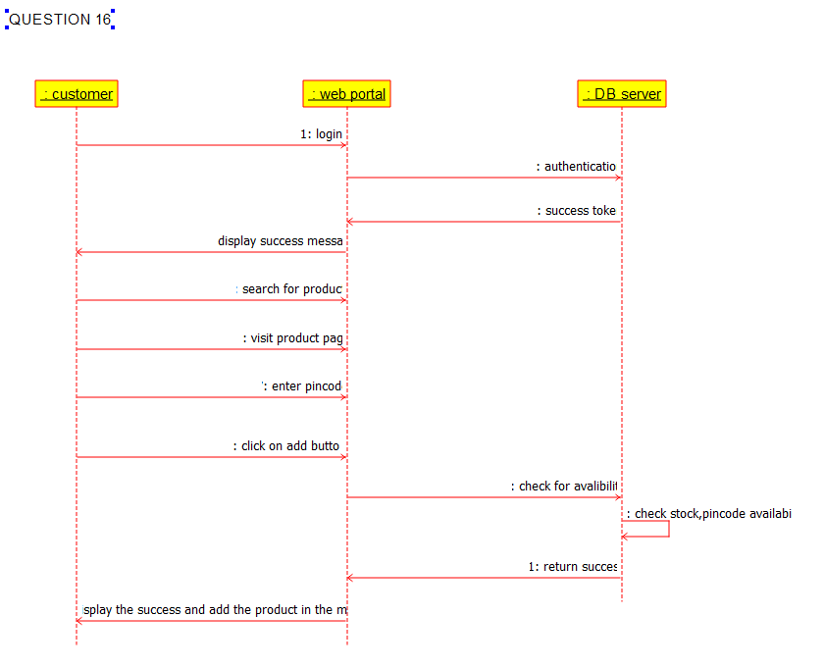

PACKAGE DIAGRAM

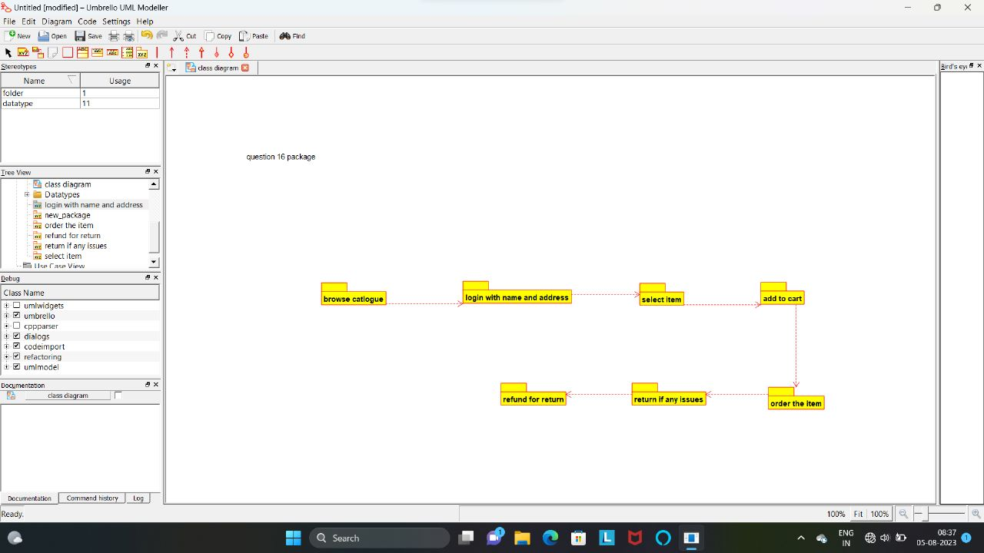

QUESTION 17:

ACTIVITY DIAGRAM

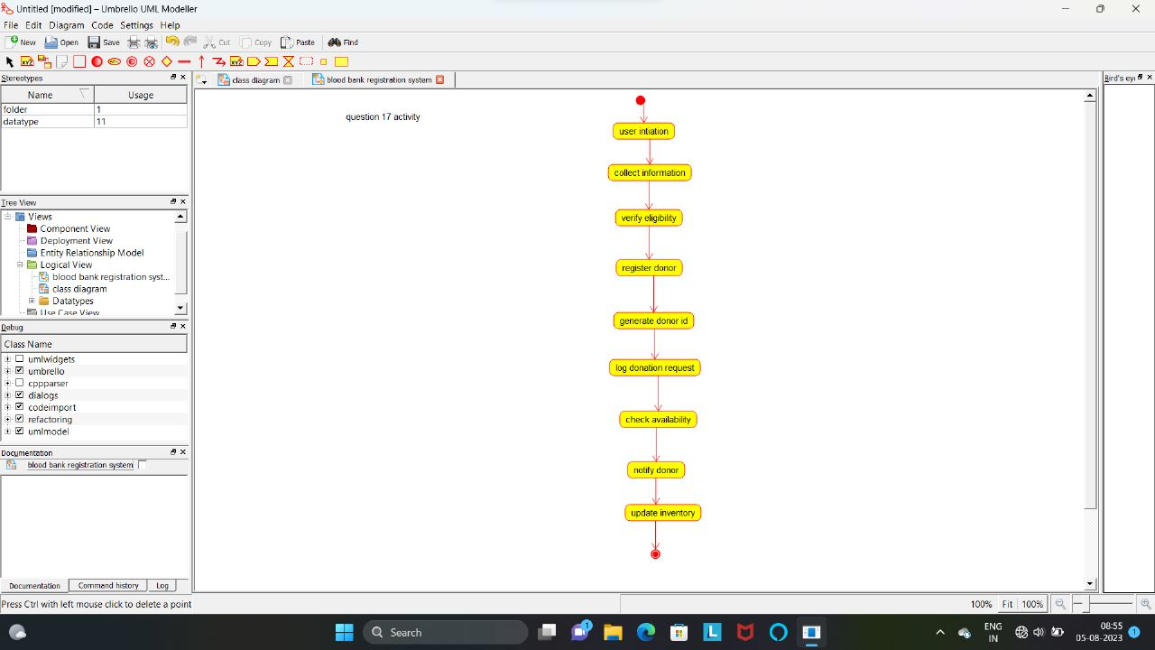

PACKAGE DIAGRAM

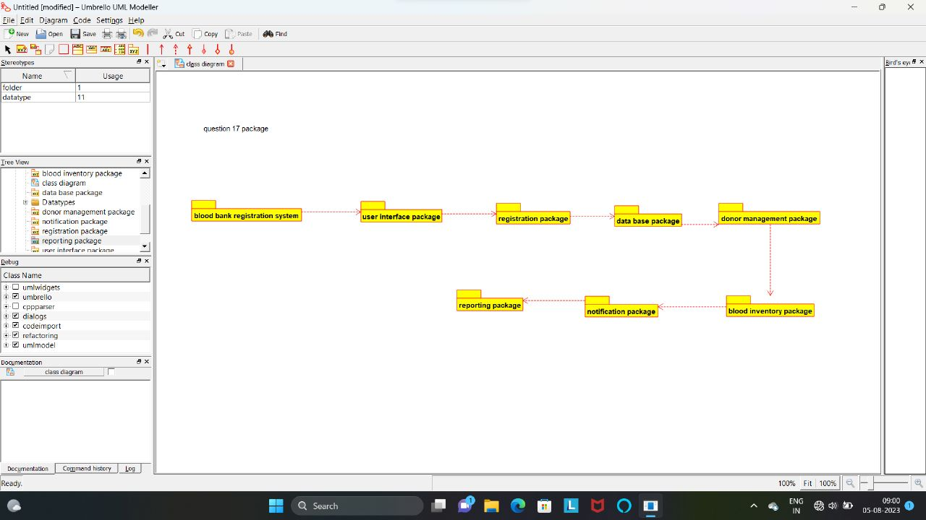

SEQUENCE DIAGRAM

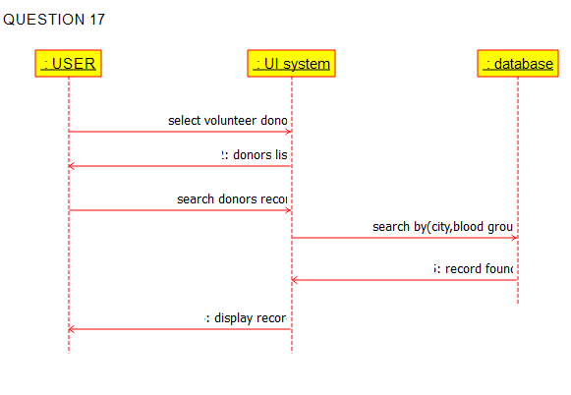

QUESTION 18:

ACTIVITY DIAGRAM

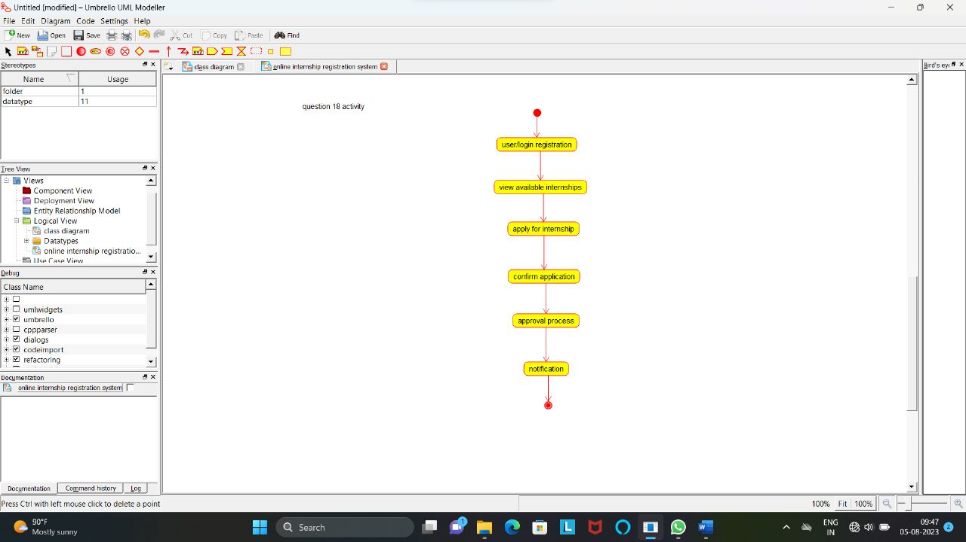

PACKAGE DIAGRAM

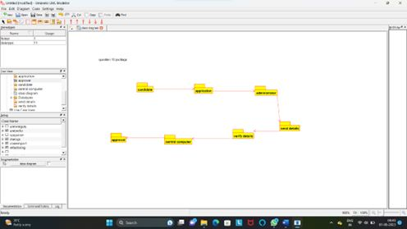

COLLABRATION DIAGRAM

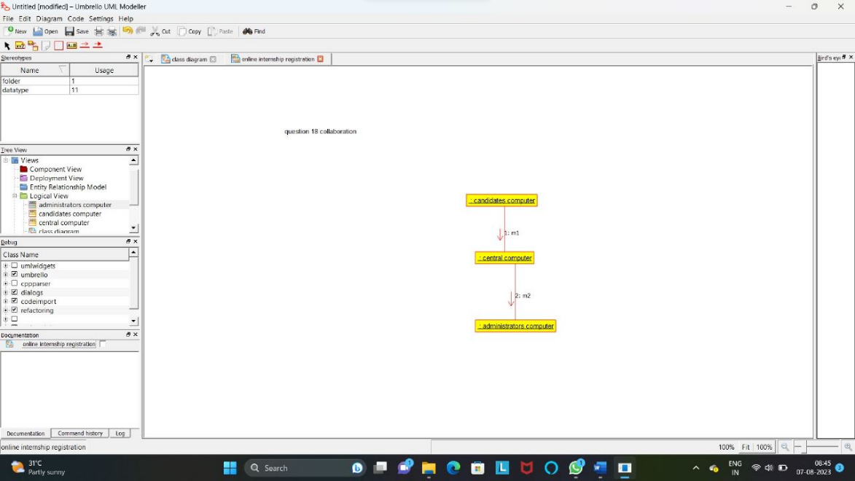

QUESTION 19:

PACKAGE DIAGRAM

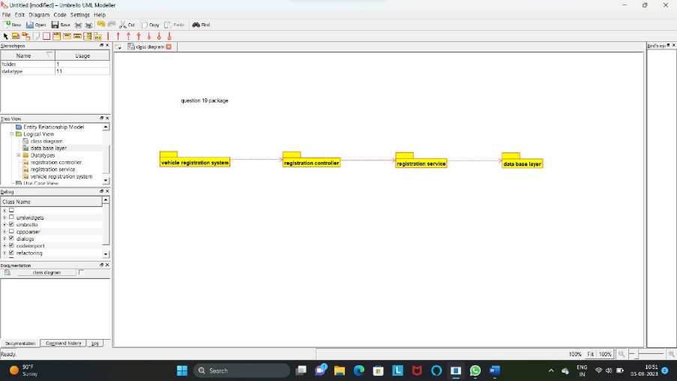

ACTIVITY DIAGRAM

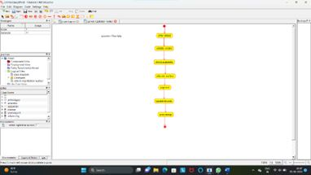

SEQUENCE DIAGRAM

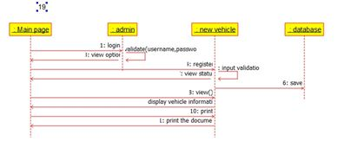

QUESTION 20:

ACTIVITY DIAGRAM

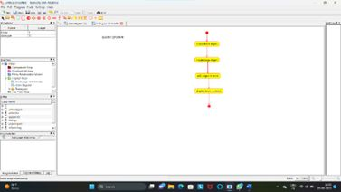

DEPLOYEMENT DIAGRAM

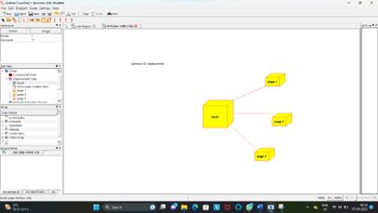

PACKAGE DIAGRAM

